Family Feud Guide - General

1. Check SONA for participants - see SONA guide.
2. When the participant arrives:
   1. Make sure they are in the right place and time (with this study you need to not run people at the wrong time).
   2. Give them a consent form to sign.
3. Take a family feud guide to be able to score the experiment.
4. Load the family feud guide.
   1. 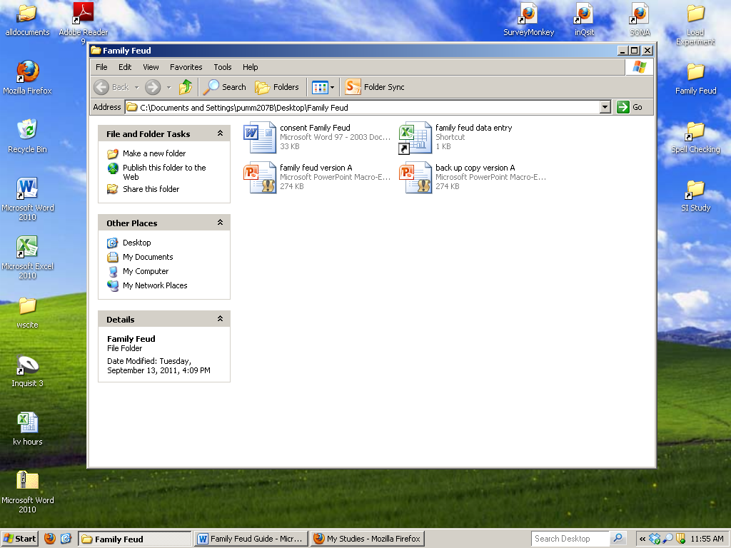
5. Go to the instruction screen, and allow them to read the instructions.
   1. 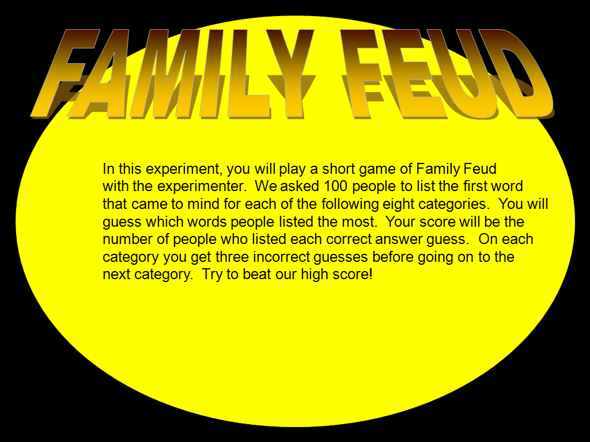
6. Get to the selection screen and allow them to pick a category.
7. 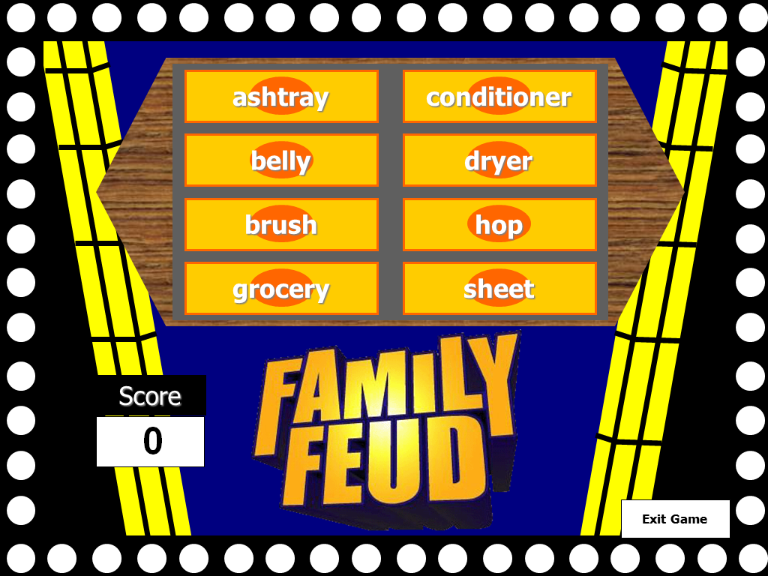
8. Click on the word to go to that category.
9. 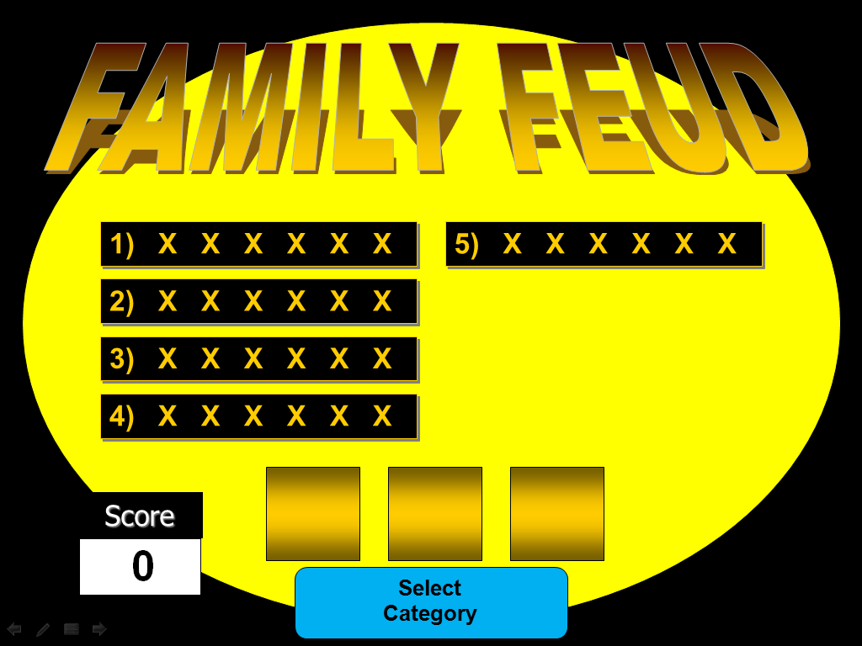
10. Let them guess words for that category.
    1. Click on the words that they get right.
    2. Click on the yellow squares when they get one wrong.
    3. When they have three wrong answers or give up, click select category.
11. 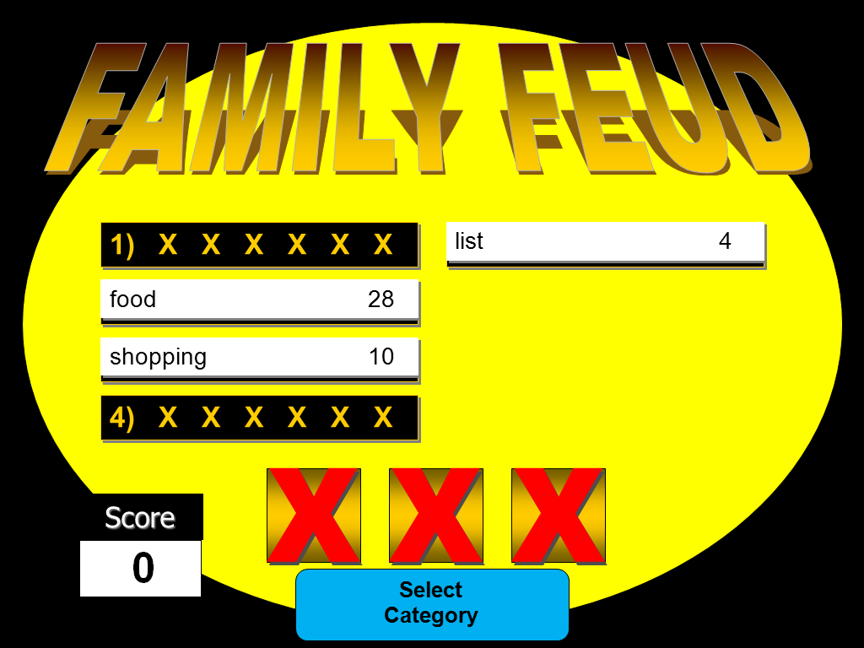
12. Total their score based on the number of people for each word they got right (28+10+4 = 42).
13. Change their score on the score piece on the category slide.
14. 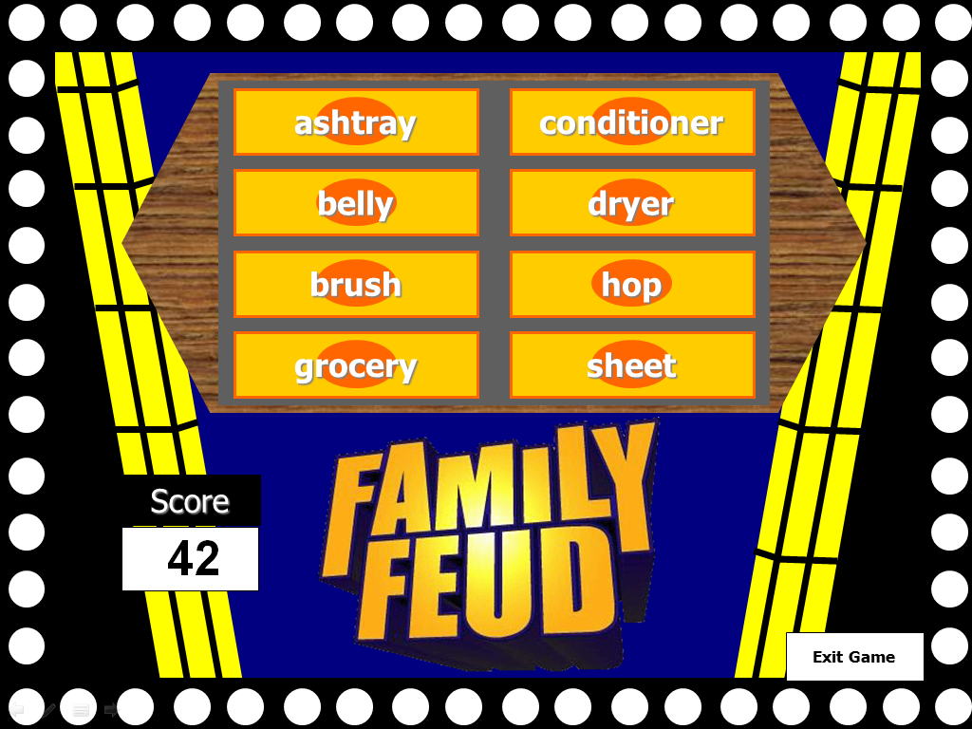
15. On the score sheet:
    1. Highlight the ones they get right.
    2. Write down all the guesses.
    3. Keep score.
16. When they finish hit exit game and tell them they can leave.
    1. End the power point and DO NOT save.
17. Give them credit on SONA.

**Entering information into the scoring guide.**

1. Open the scoring guide (family feud data entry).
2. 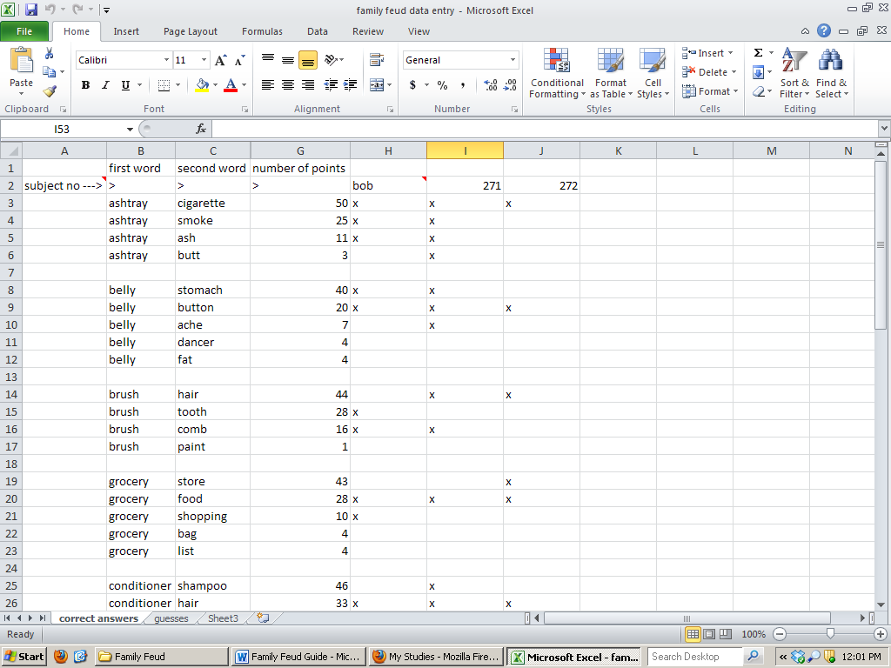
3. Make up a fake subject number (write this on all sheets of the participants game sheets).
4. Put an x for each word they got correct.
5. Click on guesses.
6. 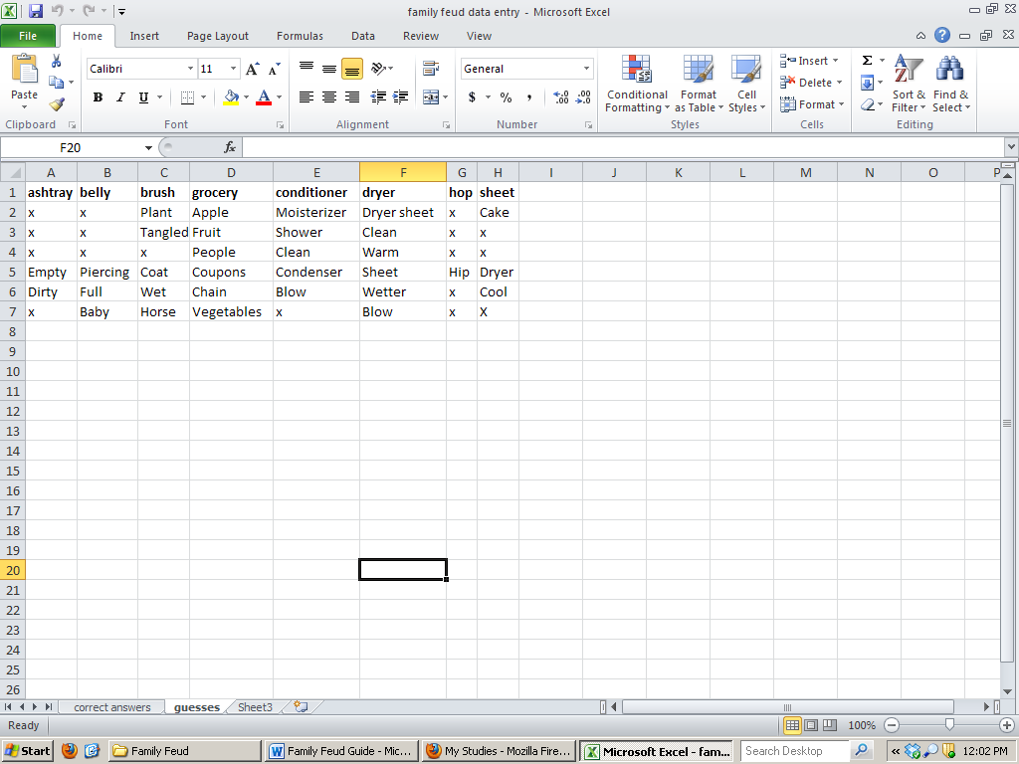
7. Type in their guesses for each word (you can put X in the boxes they didn’t guess anything to keep it even for each subject).
8. SAVE the excel sheet.
9. Put the forms in the entered slot on the wall.